MIS 380 - Fall 2025
Authors
Kate Ellestad: Project Manager, BI Analyst Ramla Mohamud: Visualization Lead Jahne Brevard: Data Engineer
2024 Minnesota Labor Market Analysis

Contents
Intended Audience 2
Executive Summary 2
Key Findings & Analysis 3
Cost of Living & Wage Sufficiency 3
Vacancy Pressure 4
Unemployment Patterns 5
Attrition 7
Summary of Findings 8
Action Steps & Recommendations 8
Conclusion 9

Intended Audience
This report is written for workforce planners, regional development boards, policymakers, and employers across Minnesota who make decisions about wages, training programs, and hiring practices. Its goal is to help these groups understand where labor shortages, turnover, and cost of living pressures are strongest, and why those differences matter for the state’s economy.

Executive Summary
Minnesota’s labor market in 2024 shows strong job growth but also persistent differences between regions. No area currently meets the 1.7 wage-sufficiency benchmark, meaning the average single adult still cannot follow the recommended 50-30-20 income split for necessities, wants, and savings. Job vacancies remain highest in health care, education, and hospitality, which continue to face recruitment challenges because experience and tenure rarely lead to higher pay and career paths are often limited. At the same time, unemployment claims remain highest in Northeast and Southeast Minnesota, where tourism, hospitality, and other weather-dependent industries slow down during the winter months. Together, these patterns show an economy that is growing overall but not evenly and one that needs region-specific wage targets, off-season training opportunities, and stronger retention efforts to keep workers engaged throughout the year.

Key Findings & Analysis

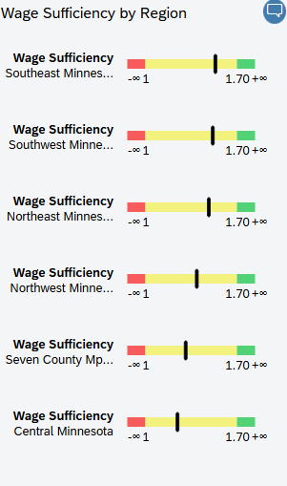
Cost of Living & Wage Sufficiency
The data shows clear differences in monthly living costs for single adults aged 19–55 across Minnesota’s regions. Housing and transportation make up the largest share of expenses statewide, but residents in the Seven County Minneapolis–St. Paul area face an average monthly cost that’s about $600 higher than those in rural regions. According to the DEED Cost of Living Tool, housing remains the most significant factor driving regional wage sufficiency. These differences show why wage sufficiency should not be treated as a single statewide measure. Regional benchmarks are needed to reflect actual household budgets and improve wage planning accuracy.
Figure 1 Wage Sufficiency Relative to 1.7 Benchmark
Across all six Minnesota regions, average wages fall short of the 1.7 sufficiency benchmark, meaning that single adults with no children cannot meet the recommended 50-30-20 income balance of necessities, discretionary spending, and savings. Regions in the Southeast and Southwest come closest to the threshold, while Central Minnesota lags the most. According to Investopedia, the 50-30-20 framework reflects a basic measure of financial stability, suggesting that workers earning below this level are likely to experience ongoing financial stress. This pattern highlights how cost of living differences across the state affect economic mobility, with higher wages in metro areas often offset by elevated housing and transportation costs.

Vacancy Pressure
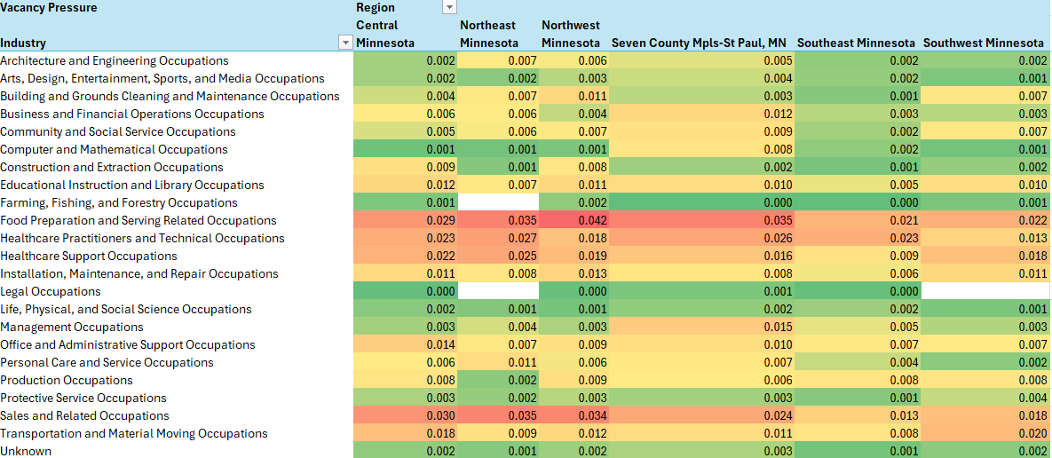
Vacancy pressure, the ratio of unemployment insurance claimants and current vacancies, is strongest in healthcare and food prep and service occupations, with the highest demand in Northeast and Northwest Minnesota. Roles in food preparation, healthcare support, and healthcare practitioners consistently show the most severe shortages, while technical and administrative positions experience relatively stable hiring conditions. This imbalance reflects structural workforce issues rather than temporary fluctuations. According to the Minnesota Department of Employment and Economic Development, healthcare and service industries continue to report the widest gaps between job openings and available workers, particularly in rural regions where fewer training programs exist. The Lumina Foundation’s report Not Just a Job: New Evidence on the Quality of Work in the United States found that occupations lacking clear career pathways and adequate compensation are less likely to retain or attract workers, even when openings are plentiful. This helps explain why sectors like health care and food service continue to experience consistent vacancy pressure despite sustained demand. In this context, Minnesota’s shortages appear most concentrated in essential but undervalued fields, where improving job quality and creating clearer career pathways may be as important as increasing wages in closing hiring gaps.
Figure 2 Vacancy Pressure Heat Matrix

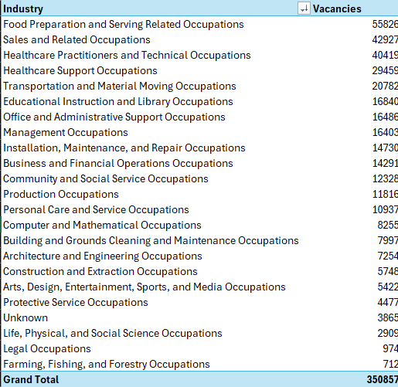
Job vacancies in 2024 remain heavily concentrated in service oriented fields. Food preparation and serving occupations account for more than 55,000 openings statewide, followed by sales and healthcare industry related positions, each having over 40,000 vacancies. Together, these three categories make up a significant portion of Minnesota’s 350,000 total openings. According to the U.S. Chamber of Commerce, these sectors have struggled to recover staffing levels since the pandemic, largely due to limited flexibility, high burnout, and competition from remote or hybrid work options. Minnesota’s data aligns with that trend, showing the largest gaps in industries that depend on in person labor and irregular scheduling.
Figure 3 Vacancies by Industry

Unemployment Patterns
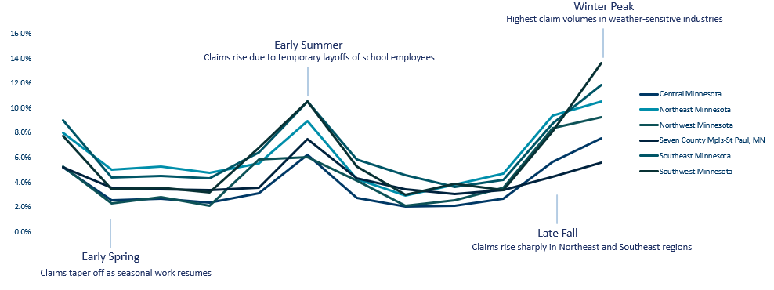
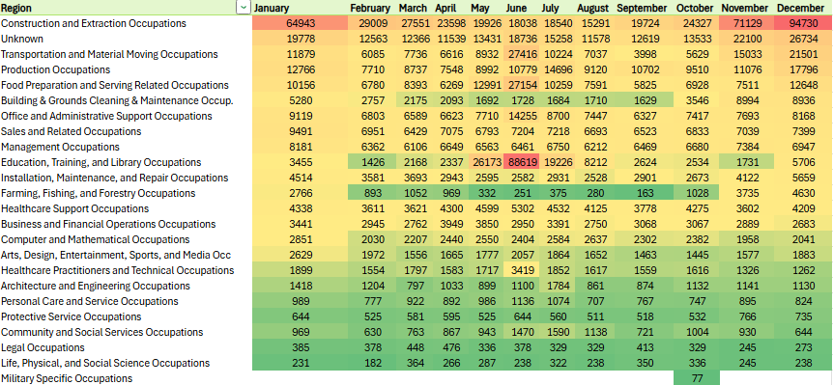
Unemployment insurance claim intensity varies throughout the year but is most elevated in Northeast and Southeast Minnesota. The seasonally unadjusted data used in this analysis captures the seasonal nature of employment in these regions, where claim volumes rise sharply between late fall and early winter and taper off by late summer. According to the Minnesota Department of Employment and Economic Development these fluctuations reflect predictable seasonal patterns tied to weather-sensitive industries such as construction, retail, and hospitality, which traditionally scale back operations during colder months. The Center for Rural Policy & Development also notes that rural regions experience elevated winter claim activity due to anticipated slowdowns rather than sustained job losses. We also see spikes in the early summer months due, mostly due to summer layoffs and discharges in the education industry. This consistency between statewide trends and local data suggests that claim intensity in these areas could be driven more by the timing of employment cycles than by overall job scarcity.
Figure 4 Seasonal Unemployment Patterns
Figure 5 Unemployment Claims by Occupation over Time

Attrition
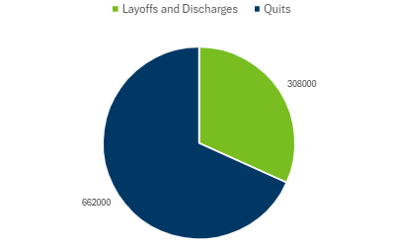
Statewide separations data show that most workforce exits in Minnesota are voluntary rather than driven by employers. Of the 970,000 separations recorded in 2024, about 68 percent were quits and 32 percent were layoffs or discharges. This pattern suggests a confident labor market in which workers feel secure leaving their jobs and pursuing new opportunities. According to LPL Research a high quits rate typically reflects strong worker confidence and elevated mobility. The Federal Reserve Bank of Minneapolis also notes that quits tend to outpace layoffs during periods of economic expansion, when employees believe they can easily find comparable or better positions. In this context, Minnesota’s high proportion of voluntary separations highlights retention challenges rather than job scarcity, reinforcing the need for employer strategies focused on advancement, recognition, and long term engagement to stabilize the workforce.
Figure 6 Employer vs Employee driven seperations

Summary of Findings
Across the six analyses, Minnesota’s 2024 labor market shows steady growth but persistent gaps between regions and industries. The Twin Cities continue to offer higher wages but remain difficult for many workers to afford, especially single adults. In Greater Minnesota, healthcare, education, and service jobs are still difficult to fill, even with a ready labor force. Seasonal slowdowns in the Northeast and Southeast continue to affect income stability, particularly in areas tied to construction and tourism. Together, these trends point to a labor market that is strong but uneven, with stability depending on better wage alignment, training access, and retention strategies across regions.

Action Steps & Recommendations
Minnesota’s labor market is strong but uneven, and closing those gaps will take focused changes in a few key areas.
First, wages should better reflect what it actually costs to live in each region. Right now, even in areas with higher pay, most single workers still fall short of the 1.7 benchmark for financial stability. Employers and policymakers should use local cost of living data when setting pay ranges and creating incentives to help people stay in their jobs.
Second, training programs should focus on skills that can transfer between industries. Jobs in healthcare, education, and service fields have the most openings, not because people aren’t willing to work, but because the requirements and career paths can be hard to navigate. More access to training partnerships, tuition support, and apprenticeships would help workers move into these jobs and stay there.
Third, regions that rely on seasonal work, like construction and tourism in the Northeast and Southeast, need more stable, year-round job options. Off-season projects, cross-training, and local infrastructure work could help people stay employed and reduce the cycle of layoffs and unemployment each winter.
Finally, employers should focus on keeping the workers they already have. With most job separations coming from people quitting on their own, it’s clear that many are leaving for better pay, flexibility, or growth opportunities. Offering clearer career paths, flexible scheduling, and better support for employee well-being can make jobs more appealing and help reduce turnover across industries.

Conclusion
Minnesota’s labor market in 2024 shows steady growth and strong hiring activity, but that strength isn’t spread evenly across regions or industries. The data point to a system that works well for some workers and employers but leaves others facing seasonal instability and limited career pathways. The goal moving forward should not only be to create more jobs, but to make those jobs sustainable and accessible across the state.
For the Minnesota Department of Employment and Economic Development (DEED), regional workforce boards, and local policymakers, these findings highlight where investment will have the greatest impact. Improving wage alignment, expanding cross-industry training, and stabilizing seasonal employment can help close the gaps seen in this analysis. Employers can also play a major role by focusing on job quality by offering fair pay, growth opportunities, and flexibility that encourage people to stay and build their careers in Minnesota.
Together, these efforts can help create a labor market that supports both economic growth and worker stability. Minnesota already has the foundation for success and the next step is ensuring that every region and industry shares in that progress.

